Mirage Pz 4B, C, D
Some advices to improve the kits.
If you want to build an early Pz4, the Pz4C-D from Mirage are the only game in town.
With more or less effort you can bring them to an accurate build.
Idler: The idler position is too far to the back (idler lever facing backwards) and causes a strange look. Simple counteraction: Cut the lever of idler wheel, shorten it and glue it downwards. This simple task improves the look a lot.
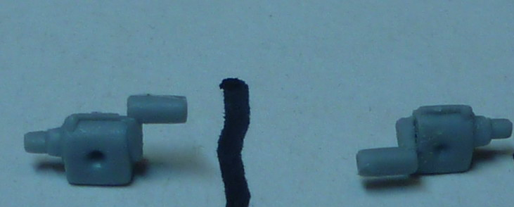

Upper hull: The engine deck is app. 2mm to short and to compensate for this there is a horizontal plate in front of the driver which was not there in reality. Fixing this one is more difficult. You have to lengthen the engine deck therefore. If you want to do it fully accurate then you have to add 1mm between turret and hatches and 1mm in length of hatches. I made a compromise. If you make a Pz4D version you have to lengthen the air intake grill also (Or use Revell/Dragon parts). For Pz4C there is a simpler solution which I will explain later.
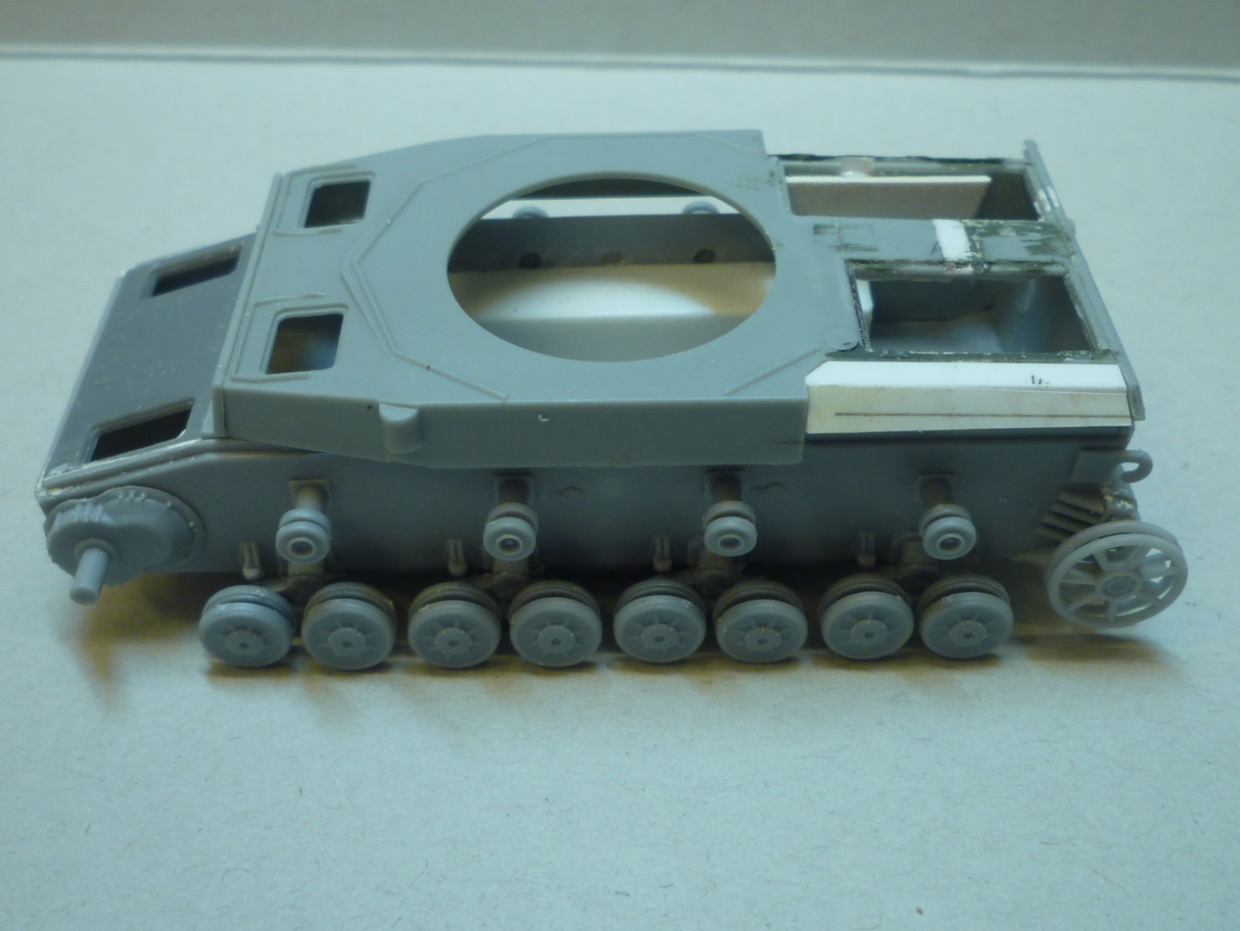
The hull width is a little bit undersized. If you are not using the (thick) add on armour I recommend to add 0,25mm sheets on the sides. So you can skip plate engraving also.

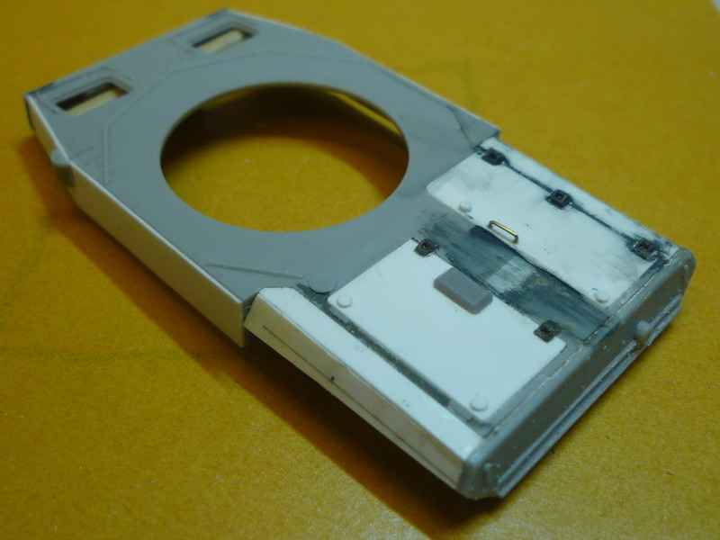

Turret: No vision block from the commander cupola is facing forward and the cupola is too low. The hatches are also too big. I cut off the cupola part from the turret extension, added a spacer made from the included cast idler wheel and turned the cupola until one visor was facing forward. For the upper end with hatches I used the spare parts from Dragons Pz4F/G with the ring sanded down to app 0,8mm. The handles are made from wire.
Check the side doors carefully. Also they are looking out of angle and full of sinkmarks in many cases it is just optical illusion from the big location pins at the back. The doors are only correct for 4D and E. More to that later.

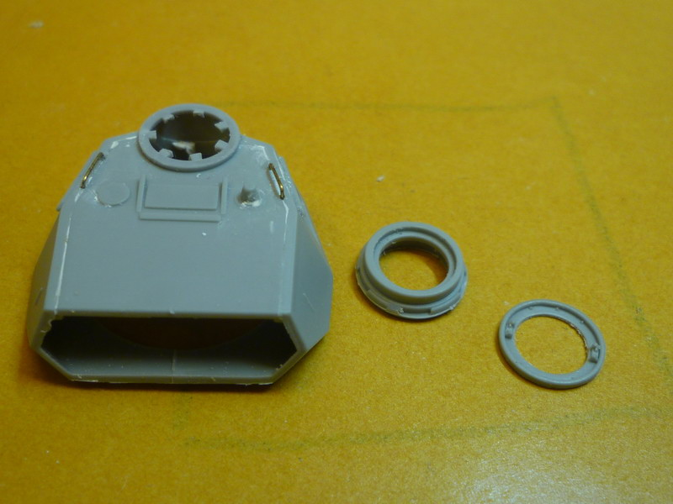

Undercarriage: apart from the sloppy fit of the suspension units and mould failures in return rollers, I do not like the shape of the early hubcaps on the wheels. They are moulded too flat. The wheels with medium hubcaps (for tanks >spring 1942) look better. (I used them for my Pz4C 1944 at Normandy)

Mufflers:
The main muffler is Pz4F-J style. Compare the one on the sprue with the muffler above, having the correct length.
The 2 outer strips around the muffler are to attach the muffler to the hull. The 2 additional strips in the middle you need only should you fix a smoke discharger.

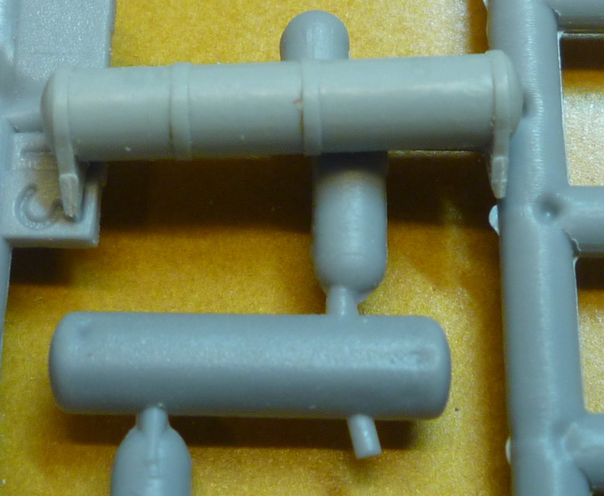
Talking about the smoke discharger: Only the later armoured version (in low quality) is included in the kit, Pz4C and early D tank however were equipped with the (missing) unarmoured version.
Brackets for Rommelkiste: These stowage bins were installed later and therefore they needed special brackets to fix them to the turrets. These brackets were U-shaped and were fixed with screws from the lifting hooks.

Specific parts for Pz4 C:
The most distinctive parts for this version are included but some have inaccuracies
Air inlet louvres:
Pz4A-C had different style of air inlets and these parts are included in Pz4B/C kits.
But these air intake grills have horizontal ribs, where in reality they were facing downwards.
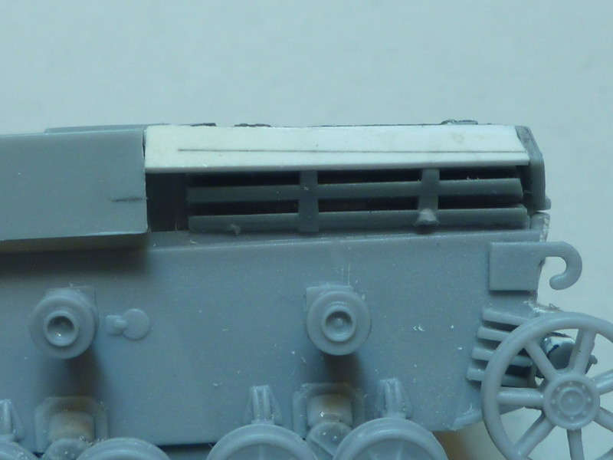
Simple improvement: Change left and right louvre and install them inside out. You have to thin the ribs but the result looks better. In reality the ribs are not covering the whole intake so no need to add the missing 2mm. Just add a plate at the forward end. Enclosed picture was made during cleaning of the ribs but I guess you get the idea.
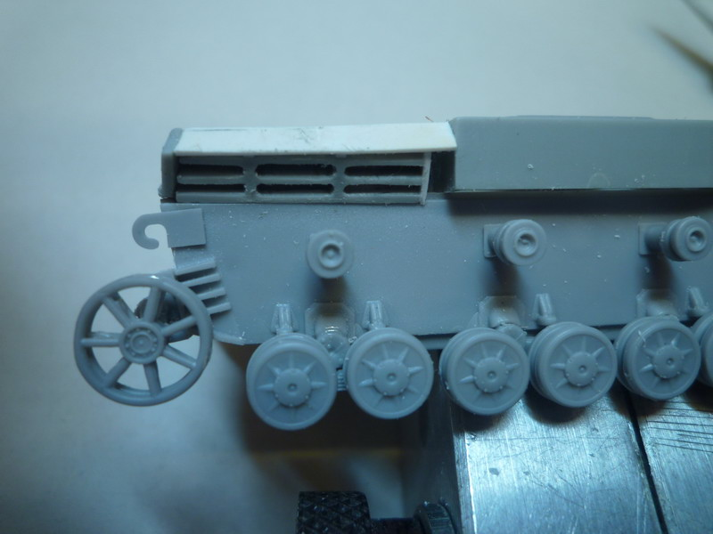
Mantlet:
The ribbed sidewalls on the mantlet are missing. I added sidewalls and created the ribs with putty and a Zimmerit tool. My mistake: the ribbed sideplate was welded inside the front plate. Therefore there should be a flat border around the “Zimmerit”
The mantlet itself has nasty sink marks and the fixing screws around the barrel are missing. I therefore recommend highly an aftermarket barrel for these kits, because it is too big a task to clean and adapt the original barrel.

Visors

One of the changes from 4C to D version was the introduction of thicker visor covers for both turret and hull. The later version is included in all the kits. I decided to build new doors with smaller visors and added earlier style PE visors from an ACE Pz 2 kit to hull and right turret side. (Left turret visor was without vision slot)

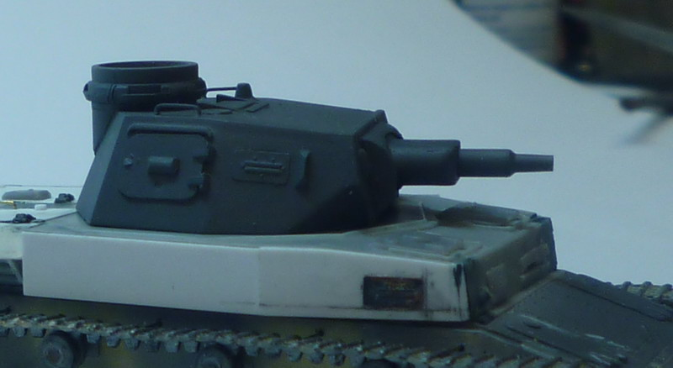

The Pz4C below was build with the improvements mentioned avove, for the Pz 4D Trop I used the lower hull with running gear from Hobbyboss Kit Munitionspanzer 4D/E. This kit has at the moment the best early running gear on the market and is a good base for modifications.

Robert Kru
